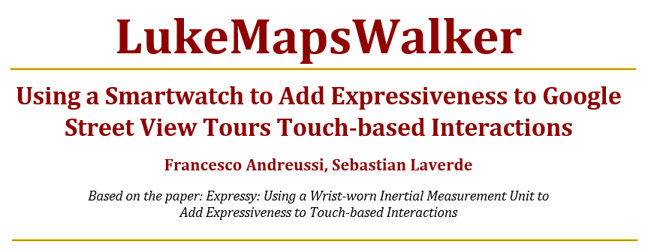

***Abstract -*** *LukeMapsWalker* is an approach for enhancing the experience of Google Street View tours using a wrist-worn inertial measurement unit (IMU) to detect and classify qualities interactions like: roll, pitch and yaw, which will then be translated into steps or camera movements inside a Google Street View tour.

**INTRODUCTION**

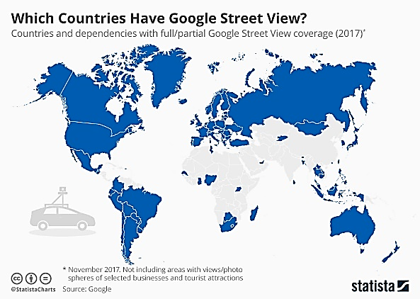Google Street View is a tool featured in Google Maps and Google Earth (also as standalone app), that provides panoramic views from positions along many streets in the world. It was launched in 2007 and nowadays it has expanded to include cities and rural areas worldwide. [1]

**Image 1. Google Street View Coverage 2017[2**]

People is using the Street View for commercial uses like publicity, video making, art, or just for personal purposes like wandering around a neighbourhood before moving in or checking nearby amenities, or perhaps to navigate tricky intersections digitally before than in real life.

On the other hand, wearables have gained special attention in the last year since the Apple *smartwatch* was released in 2015. There are many examples of work data productivity apps that can be partially viewed or managed by a *smartwatch*

To develop *LukeMapsWalker* we used a Google Street View. This view provides panoramic vision from positions along many streets in the world. Street View is available as a component of Google Maps and as a standalone mobile application for Android. The Google Maps Android API provide a Street View service for obtaining and manipulating the imagery used in Google Street View. Images are returned as photo spheres. Each Street View photo sphere is an image, or set of images, that provides a full 360-degree horizontal view and 180 degrees of vertical view. Google Play services provides support for an interactive spherical viewer [3].

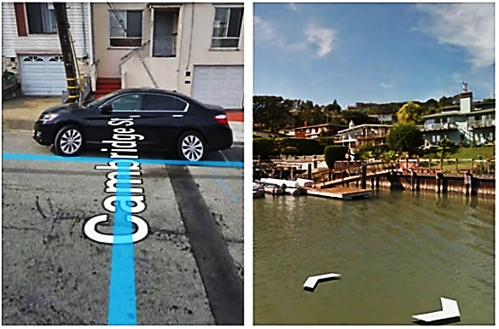

**Image 2. Blue lines for dragging movement (left). Arrows for discrete steps movement (right).**

The user interaction to explore a 3D map using Street view is based on the following:

* To look around in Street View, the user drags his finger on the screen or tap the compass to use the phone pitch and roll movement to explore the view.
* To move around, the user touches the arrows or swipes up or down on the blue line, as shown in *Image 1.a and b.*
* To zoom in, the user pinches open on the screen. To zoom out, pinches closed on the screen.

**JUSTIFICATION**

The User is subject of finger obstruction while trying to move the camera or making steps on the tour.

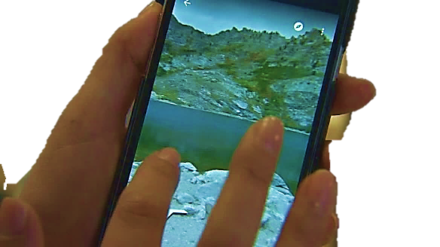

**Image 3. Finger obstruction [4]**

It’s too difficult to use the *compass* *mode[1]* while walking because the user will have to move around with the device or move it, making the navigation experience too awkward. Furthermore, if the phone (or tablet) is on a flat surface, the compass is useless because the view in the app will point to the ground. Additionally, some touch interaction to navigate often requires uncomfortable and unintuitive multi-touch gestures to move, pitch the camera and rotate the view. Both body full body movement and/or screen movement are limitations that could be overcome integrating a wearable device like the *smartwatch.*

It is not possible for the user during a Street View tour to look around while moving at the same time. The user must choose between moving or looking around, making the tour too sequential.

With *LukeMapsWalker* we can use movements of the user’s wrist to manipulate the 3D view directly, enhancing the integration and the making it more comfortable and efficient to use.

**THE PROJECT: *LukeMapsWalker***

The basic idea is to use the gyroscope data during the *enrichment* phase as described in the *Expressy* paper [5] (when the user is touching the screen) to change position, camera angles, and run other tasks, while on a navigable street.

What we propose is building an intention-response relation structure to make possible that:

* As the user pitches his wrist, the view changes moving forwards or backwards as if the user were touching forward or backwards arrows or were dragging the finger through the blue line. The pitch acceleration determines the speed of the movement on the view.
* As the user yaws his wrist, the camera changes its horizontal angle.
* As the user rolls the wrist, the tour continues making a turn to the left or right, whenever possible.
* As the user makes a flick movement with acceleration greater than a threshold, the app saves the tour in a 2D standard view, exits the street view and returns to the original point. If the acceleration is below that threshold then the user only stops the movement or exits the view without saving the tour and returns to the starting point.

With *LukeMapsWalker’s* approach there is a stronger connexion between the user’s intentions and the app, with more natural movements that makes the navigation more expressive, rich and comfortable.

***The Data Flow***

The application process starts with the user seeing a *MapView* through the *smartphone* or tablet screen. The initial location is arbitrary.

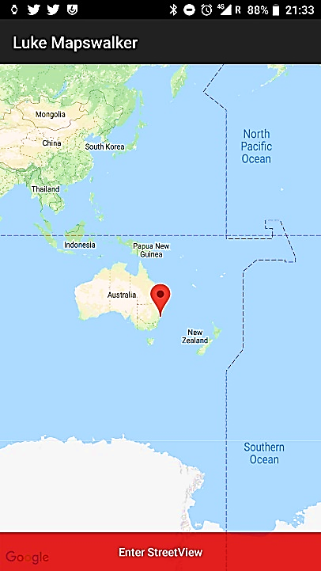

**Image 4. Initial Interface**

The user will then navigate the map and decide where (when possible) he wants to enter to the *StreetView* by hitting the *“Enter StreetView”* button. Once inside the *StreetView* the user won’t interact with the app through the device screen but by movements of the wrist wearing the *smartwatch.*

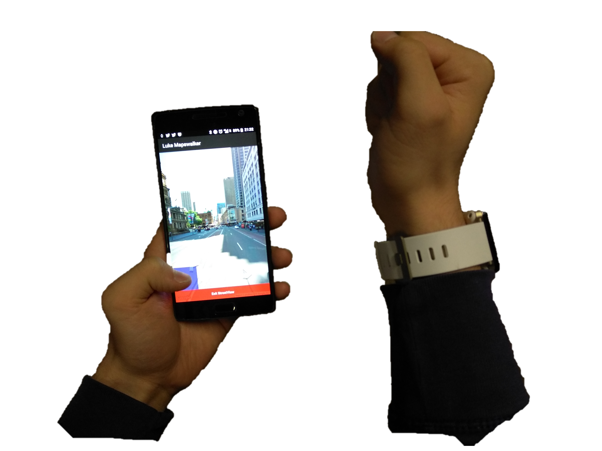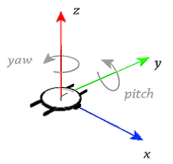

**Image 5. Smartwatch position and axis**

All the acceleration, gyroscope and rotation vector data are read and interpreted to determine which of the intentions was effectuated. We do that with threshold values for the axes, permitting us to distinguish between activities.

Initially the gyroscope data is seen on the *smartwatch* screen:

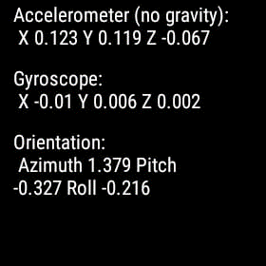

**Image 6.** **Data on Smartwatch screen**

To start controlling the interactions with the wearable, and pause it, the user must hit the play/pause button as shown in image 7.

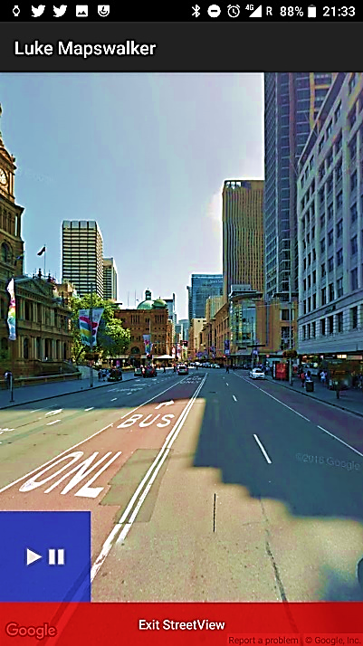

**Image 7. Start/Pause wearable control**

**MAYOR ISSUES**

1. Initially we had some trouble with the communication between the smartwatch and the smartphone.
2. Due to the busy activity inside the data buffer, sometimes the data freezes.
3. No map displaying when changing between the MapView and the StreetView. We tried with fragments, then with a *viewchanger* and finally with two views, handling visibility attributes.
4. The rotation vector from which we derive the orientation of the smartwatch was always null, so determining the size of the steps on the streetView, because we had to use the gyroscope data, which is an angular velocity (rad/s). At the end we just checked if the data was beyond a threshold or not to make larger or shorter steps.

**DIFFERENCES TO *EXPRESSY***

*Expressy* detect and classify qualities of touch interactions like ours: roll,  
pitch but additionally with tap force and flick force as well. Nevertheless, they never talk about a *yaw* movement like LukeMapsWalker.

In Expressy the interactions occur in three different periods: *intention, enrichment and follow-up/recovery.* We are only working with inside the *intention* period. However, in LukeMapsWalker the gyroscope data during the intention period plays a significantly higher role than in the original Expressy paper.

*Expressy’s* introduce a conceptual model that describes the expressive interaction opportunities by hand movements information. After discussing utility and feasibility of the model, they presented some applications to add expressiveness to some intentions inside different kinds of apps. LukeMapsWalker is one of these many applications.

**REFERENCES**

[1] GSV purpose:

https://en.m.wikipedia.org/wiki/Google_Street_View.

[2] GSV Coverage:

https://www.statista.com/chart/11778/which-countries-have-google-street-view/

[3]GSV panorama:

https://developers.google.com/maps/documentation/android-sdk/streetview

[4]ihttps://www.kolotv.com/content/news/Street-View-now-available-at-state-parks-lakes-373164781.html

[5] Gerard Wilkinson, Ahmed Kharrufa, Jonathan Hook, Bradley Pursglove, Gavin Wood, Hendrik Haeuser, Nils Y. Hammerla, Steve Hodges, Patrick Olivier. (2016). *Expressy*: Using a Wrist-worn Inertial Measurement Unit to Add Expressiveness to Touch-based Interactions

[6] Smartwatch Gyroscope’s DF:

www.researchgate.net/figure/Readily-available-IMUs-provide-movement-data-WaveTrace-relies-on-yaw-and-pitch-values_fig2_316611968/amp?source=images

1. With the *digital compass* enabled, it will rotate the onscreen map to match the direction you’re facing.